The Lake Elkhorn Walk, Bike, and Run
May 21st – 7:30 a.m. – 10:00 a.m.
- Kick off prayer at 7:30 a.m. at Dockside.
- If you miss the kick-off prayer, we will see you on the trail. Relax, walk, smile, wave, and take pictures.
- We will be walking through 10:00 a.m., but feel free to stay for as long as you would like.
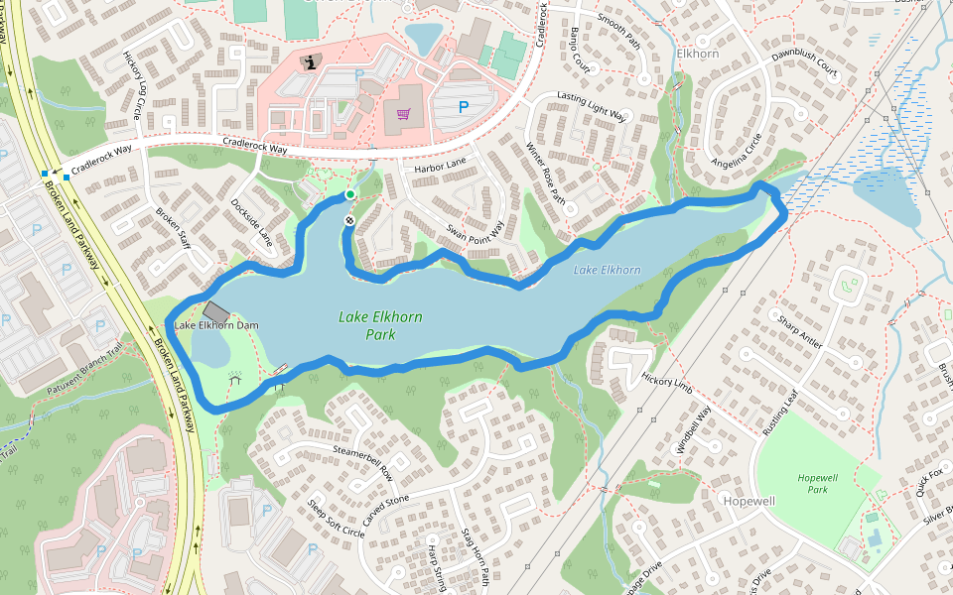
- Enjoy!

Parking Area One Parking Area Two Kick-Off Prayer

