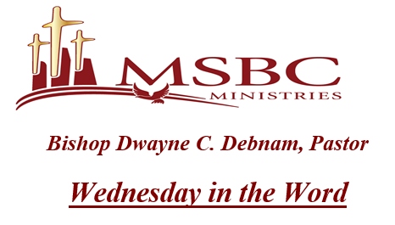
November 2, 2022

- He understands that if he is going to LIVE UP TO THE STANDARDS OF THE KINGDOM, he must ___________________________ scripture enough to LIVE IT.

- The trustworthiness of the Scriptures lies at the __________________________ of our trust in God.

- The WORD OF GOD is the _____________________ for every decision that we make.

- When your heart is with God, scripture is A _______________ OR A____________________.

- But SCRIPTURE is the ______________________ WORD OF GOD.

- SCRIPTURE is the _____________________ OF GOD.
- SCRIPTURE is the _____________________ OF GOD.
- SCRIPTURE IS THE PLAN OF GOD...
- An ______________________ LIFE is a LIFE THAT IS FILLED with _____________________.
- An ____________________ of the authority of scripture.
- A BELIEF IN THE _____________________ AND POTENTIAL OF THE WORD.
- An __________________ Christian life, is a life that LIVES THROUGH THE WORD.

