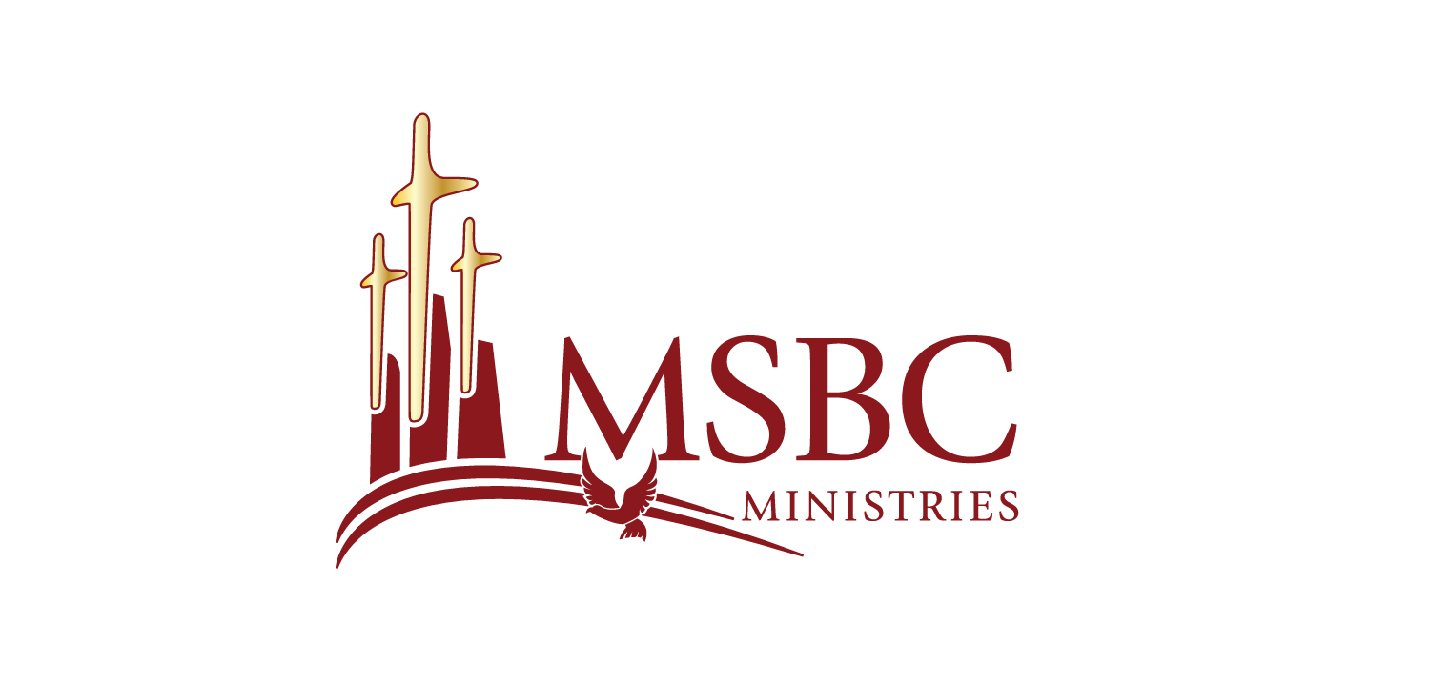

Bishop Dwayne C. Debnam, Pastor
Bible Study
May 22, 2024

- Water baptism is a public witness of your identification with Jesus while spirit baptism is the personal and private experience that identifies the person with Christ.

- The filling of the spirit has to do with power for witness and service.

- The baptism of the spirit means that I belong to His body.

- Spiritual baptism is about yielding to the direction and power of God in order to have an experience with God that connects your spirit to God’s spirit.

- Spiritual baptism is not only an individual thing, but it is the individual seeking a community of believers.

- The church was established as a place that we can find God together.

Scripture References

- Acts 2:1-12
- Acts 1:8
- Ephesians 5:18-20
- Ephesians 4:1-6
- Matthew 18:19-20

