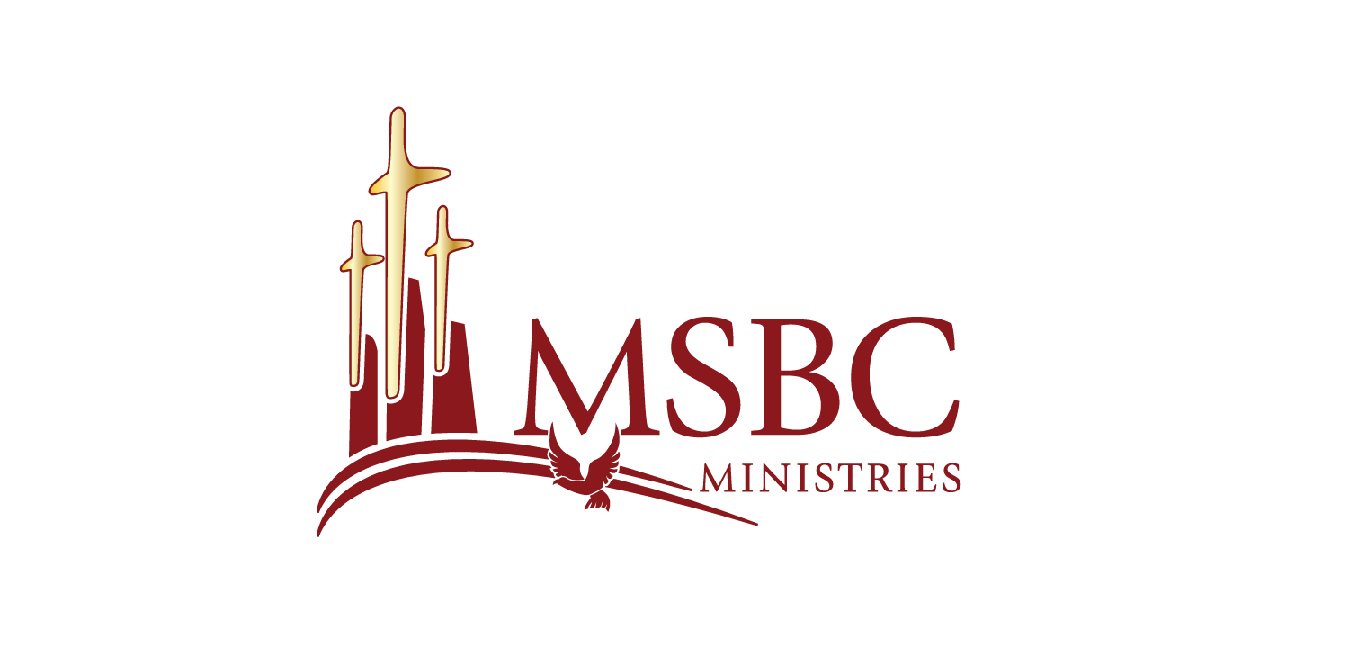
Bishop Dwayne C. Debnam, Pastor

Bible Study Sheet
October 22, 2025

Life in a Community of Faith

A Community United by Faith
In Acts 4, we witness the early believers coming together to live out their faith as the Body of Christ. Their fellowship went beyond worship—it included living, giving, and serving together in unity and love.
“All the believers were one in heart and mind. No one claimed that any of their possessions was their own, but they shared everything they had.” — Acts 4:32
This picture of the early church reminds us that faith is not meant to be lived in isolation. The believers were “a community of faith”—people united by a shared belief in God, gathering regularly to worship, grow spiritually, support one another, and live out their faith through love and service.

A Shared Belief in God
Their unity flowed from a shared belief in God. They believed so deeply that their faith could be seen in their actions. Genuine faith produces fruit—love in action, humility in heart, joy in service, and a desire to glorify God in everything.
As a community, they believed:
- In the existence and character of God—Creator, Sovereign, Holy, Loving, Just, and Faithful.
- In the Word of God as truth and authority.
- In the promises of God that sustain and guide them.
- In God’s plan of salvation through Jesus Christ.

Faith in Action: Love, Justice, and Liberation
The early church lived their theology. They not only preached the gospel but embodied it through compassion and justice.
“And God’s grace was so powerfully at work in them all that there were no needy persons among them.” — Acts 4:33–34
Their generosity reflected God’s heart for justice and equity—redistributing resources to meet needs and uplifting the marginalized. This aligns with what is often called Liberation Theology, which views the gospel as a call to free people from all forms of oppression—spiritual, social, and economic.
The Acts community demonstrated that true faith transforms both hearts and society. They didn’t just pray about need; they acted to eliminate it.

Speaking Truth to Power
Acts 4 also reveals a bold faith that speaks truth despite opposition. Peter and John were arrested for preaching about Jesus, yet they refused to remain silent.
Their courage models for us what it means to trust God above human authority. They believed that God was their ultimate protector, and they acted accordingly.

A Shared Trust in God
A community of faith not only believes in God but also trusts God together. That trust shows up in collective action:
- They spoke boldly, trusting God over man.
- They prayed together, trusting God for guidance and strength.
- They gave sacrificially, trusting God to provide.
- They remained unified, trusting the Holy Spirit to lead them as one body.
True trust in God transforms how we live and how we love—together.
“All Scripture is God-breathed and is useful for teaching, rebuking, correcting and training in righteousness.” — 2 Timothy 3:16
A word that does not shape how we live is a word not taken seriously. As a community of faith, we must allow God’s Word to shape our values, decisions, and actions, just as the early church did.

Reflection Questions
- What does it mean for us to live as a “community of faith” today?
- How does our shared belief in God show up in how we care for one another?
- In what ways can we speak truth to power while showing love and grace?
- How can we practice radical generosity and unity like the early church?

Scripture References

Acts 4:32–37
Acts 4:19–22
Acts 2:22–25
Acts 4:33–35
2 Timothy 3:16

