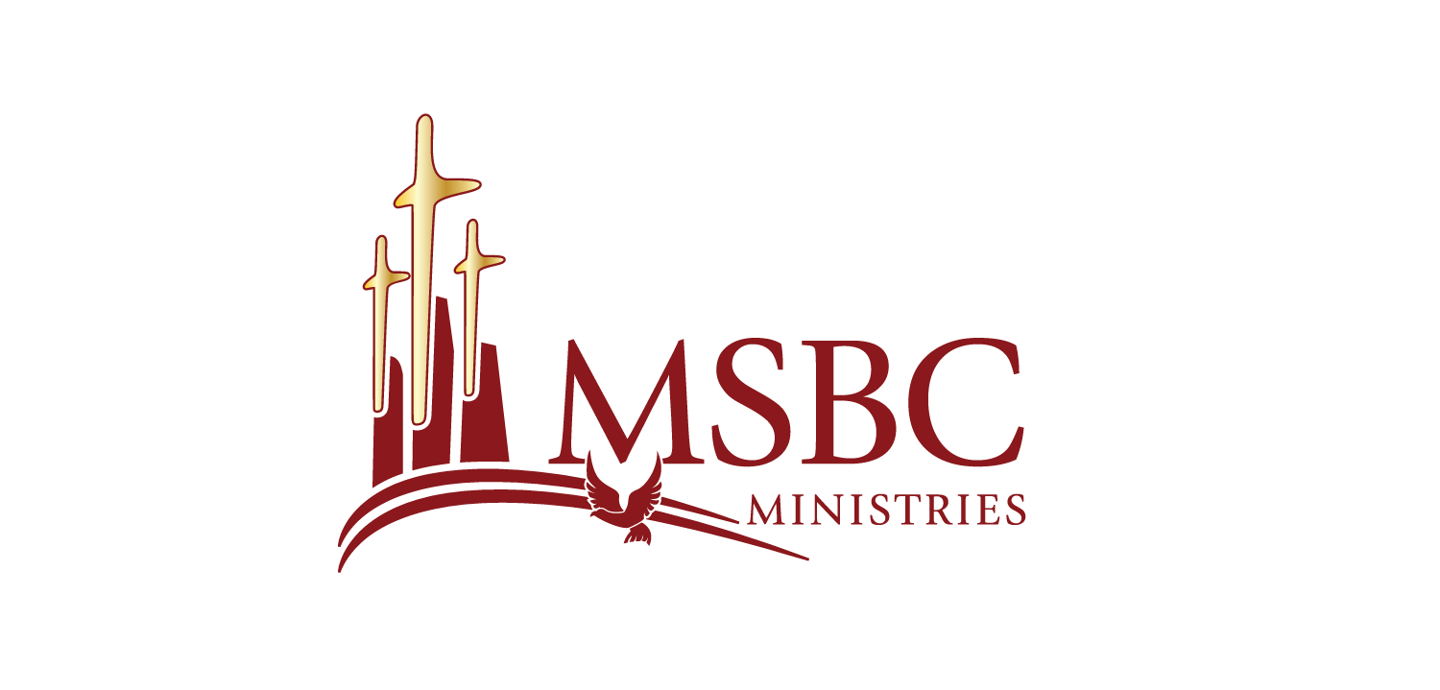

Bishop Dwayne C. Debnam, Pastor

Bible Study Sheet
May 20, 2026

Pentecost Sunday: More Than a Moment — A Movement
Pentecost Sunday reminds us that the church was never meant to survive on personality, programs, tradition, or talent. The church was born by the power of the Holy Spirit. Acts 1 and 2 reveal what happens when the Spirit of God moves among the people of God. The Spirit equips the church to overcome the challenges of culture and empowers the church to remain a witness in the earth for nearly 2,000 years.
The Spirit Forms a New Community
Acts 2 begins with the Spirit filling the room and ends with the Spirit shaping the church. The deeper question is not simply whether the believers spoke in tongues, but what kind of people the Spirit caused them to become. When the Spirit rested on them, fear became boldness, silence became witness, and scattered followers became a covenant community. Pentecost was more than emotional excitement; it was divine empowerment.
Reflection Questions:
• What evidence of the Holy Spirit’s work can be seen in your daily life?
• Are you seeking an emotional experience with God or true transformation by God?
The Evidence of a Spirit-Filled Church
Acts 2:42-47 shows that the early church devoted themselves to teaching, fellowship, prayer, breaking bread, generosity, and worship. Their anointing was revealed not only in what they felt but in how they lived. John Stott said, “As a body without breath is a corpse, so the church without the Spirit is dead.” Pentecost teaches us that discipleship through the Spirit produces inward transformation that becomes visible through outward habits.
Reflection Questions:
• What habits in your life show commitment to God’s work?
• How can you better devote yourself to prayer, fellowship, and God’s Word?

The Spirit Creates Kingdom Community
The early believers did more than gather together; they became a living witness of God’s power in the world. Pentecost produced a Kingdom-shaped community where people cared for one another, shared resources, served the needy, and demonstrated unity. The church does not grow through gimmicks, charisma, or performance. The church grows when the Spirit gives life, the Word is proclaimed, the community remains faithful, and the Lord adds to the church.
Reflection Questions:
• How can the church better serve and impact the surrounding community?
• In what ways can you help make the church a visible witness of God’s love and power?
Pentecost: From a Moment to a Movement
Pentecost reminds us that the Holy Spirit did not come merely to give the church an experience; the Spirit came to give the church an identity. The evidence of Pentecost was not only tongues of fire, but teaching, fellowship, prayer, generosity, unity, and witness. The Spirit did not fall so the church could have a moment; the Spirit fell so the church could become a movement. The Spirit filled the believers, shaped their character, and empowered them to become good news to the world.
Reflection Questions:
• What does it mean for you personally to be part of God’s movement in the world?
• How can your church reflect the visible habits of people living under the influence of God?
Scripture References
Acts 1:8
Acts 2:1-4
Acts 2:42-47

